Cable Rating Cover Sheet
This document is to be used as a template for submitting a rating assessment to be reviewed by Ausgrid. It does not need to be used, but all aspects of this template should be included in the rating submission.
Yellow highlighted text are examples
Instructions are in Italics; they do not need to be included in the submission.
Note – A before and after assessment will be required by the ASP performing the rating assessment if there are existing assets that will be affected by this installation (i.e. the installation comes within 4m of an Ausgrid Asset). Ausgrid will need to approve any de-rating of Ausgrid assets.

Project Name: | New 11kV Feeder
Ausgrid Project number: | -
RSQR Report Number:  (If known) | 2020_065A
Date of last submission: | Only required if another rating assessment has been submitted for review for this project.
Submission contact details:

Table of Details for endorsement:

Endorsement | Details | Comments
Cable | New 11kV feeders: 11kV 630mm2 Cu XLPE insulated Single core cable
Bonding | Single Point Bonding
Target Ratings | Proposed Connection -  Each feeder has 2 cables  Feeder to achieve Ratings of 2000A (normal)

All Underground Ratings Submission MUST include:
- Design Drawing compliant with NS104.
- Cymcap models (MDB File) if available, these are the computer files of the models used to assess the ratings.
- Cable Verifications for every cable used in models.
- Cable Route.
- All Cross Sections.
- All Ratings Calculations.
- TR Test reports
- Location of TR trial holes
- Any request for dispensation.

Please note:
Ausgrid will review all submissions as soon as possible, however, there may be instances of delay when the submission is incomplete or where further information may be required.

You will be notified if any further information is required.

Where there is an incomplete submission or further information has been requested, ratings assessment will be put on hold until all information requested has been provided.

Cable Rating Submission
Cable Rating Submission Template (for submissions with accompanying Cymcap model).

1. Cable Verification
Perform cable verification for every cable found in your model to the following conditions and present the results.

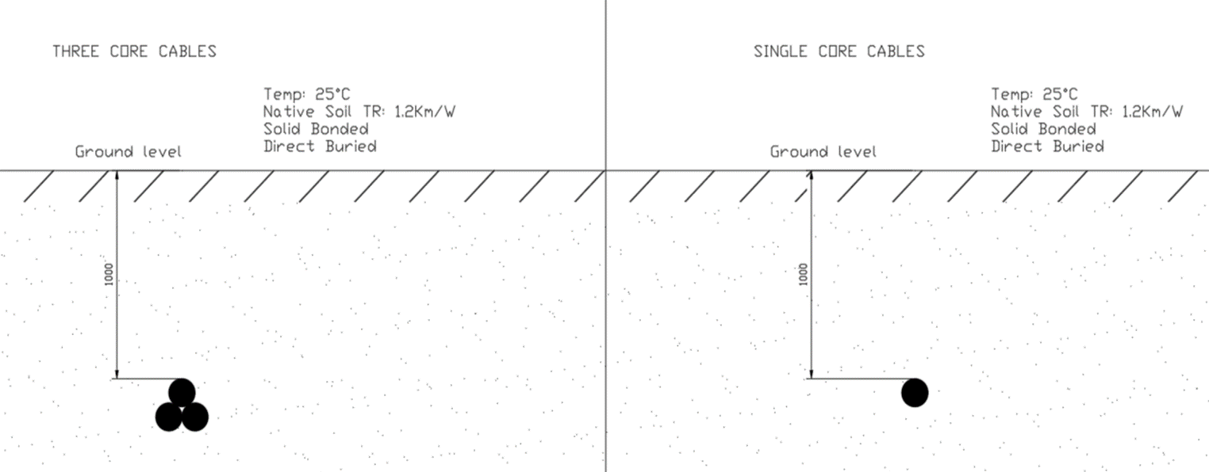

NS272 s5.0: All individual cable models must be formally verified against the manufacturer’s data sheets for the cables, regardless of the ratings software used. This verification documentation must form a part of the electrical design.

Cable ID | Cable Name /Cable Size / Type | Conductor Temperature  [°C] | Ampacity Achieved by ASP  [A] | Ampacity Achieved by Manufacturer  (If known)  [A] | Ampacity Achieved by Ausgrid  (If known)  [A]
Cable 0 (Example) | G3-11 - 500CU3 XLPE | 90.0 | 607.5 | 610 | 610
Cable 1 | C011-547 | 90.0 | - | - | 662
Cable 2
Cable 3
Cable 5
Cable 6

2. Standard Cross Section Validation

Select one cable from the cable verification table.
Construct a typical cross section using the following details.
Perform Cross section verification simulation and present the results, this confirms correct use of the ratings calculation tool.

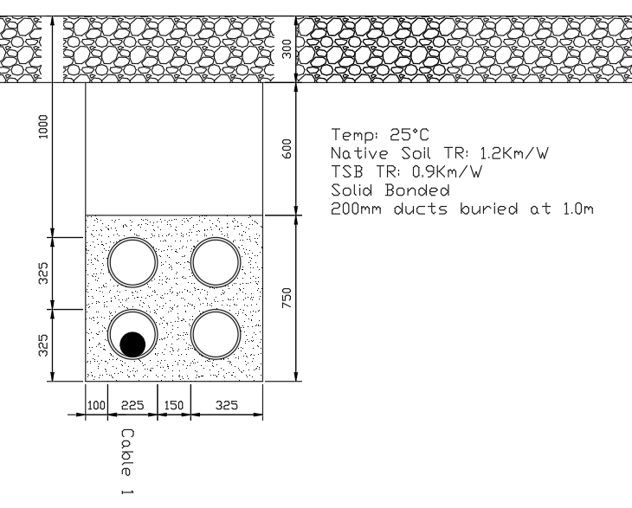
Cable ID | Cable model | Normal (A) | Temperature  (°C) | Comments
Cable 1 | C011-547 | 593 | 90

3. Ratings Calculation Review
See NS272 s5: You will be required to provide the following for assessment:
- The assumptions used.
- The entire cable route.
- The identified cross sections for ratings analysis.
- Design drawings including cross sections. The Cross-section ID in models must match design drawings.
- Thermal Resistivity test reports.
- Design must comply with NS130, 168 and 272.
- Manage the risk of dry out by ensuring the 50°C isotherm is fully within the thermally stable material or fully dried TR is used with the 50°C isotherm.

For each identified cross section, construct the cross section in Cymcap and perform ratings simulation and present the results in a summary table.
Where necessary, please state the assumptions used in your ratings assessment.

3.1 Assumptions and Target ratings

 | Summer | Winter
Ambient Ground Temperature: | 25°C | 18°C

Description | Value
Sheath/Shield Bonding: | Single Point Bonded
Target Ratings: | 2000A Per Leg (Normal)

3.2 Relevant Thermal Resistivity Test Reports

Cross Section | TR Test Location | TR @ 3% Moisture content | Fully Dried TR (Km/W) | Comments
Backfill | - |  | 0.9
Section 7  248524 | TH2 | 2.35 | 2.91 | Test Report:  141901 rev2
- | TH1 | 0.86 | 1.11 | Next closest Trial hole

3.3 Cable Route, TR Trial Holes & Cross Section Location
Attach plan view of cable route with cross section location identified and TR Trial Hole locations. TH1 – trial hole 1
TH 1
Case 2
Case 3
TH2
Case 1
Destination Substation
Source Substation

3.4 Design Review
The basic requirement will be that all Cymcap models must match the design drawings.
Provide commentary on design / cross sections (if required).
Attach details for every Cross section identified in the cable route
Case 1 – Description of case
Drawing: 248525_03R1.pdf
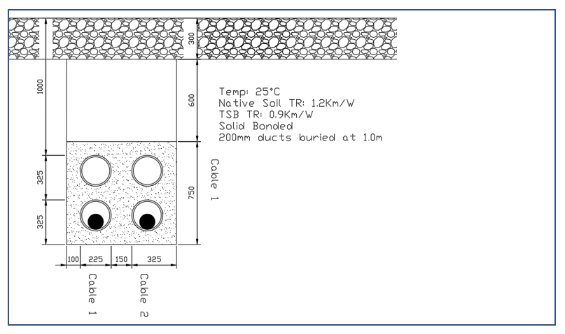
Case 2 – Description of case – if a before and after assessment is required to compare the effect of the new cables, then two separate load models of the case should be submitted, , for review by Ausgrid:
- One with no load on the new cables (or no new cables/banks in the cross section at all) and all other cables run to max operation temperature or known loads, and,
- One with the new cables with proposed load and the reduction on the nearby cables due to the proposed loads.
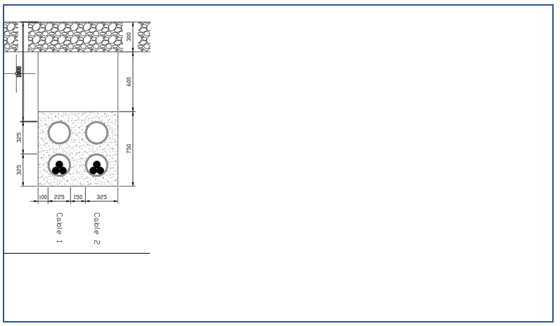

3.5 Ratings Calculation Table (If Required)
Summer Continuous rating table.
Case | Cable ID | Normal (A) | Temperature  (°C) | Abnormal (A) | Temperature  (°C) | Comments
1 | Cable 1 | 603 | 90 | - | - | Both Cables in Service
1 | Cable 1 | - | - | 667 | 90 | One Cable in Service
2 | Cable 1 | 603 | 90 | - | - | Both Cables in Service
2 | Cable 1 | - | - | 667 | 90 | One Cable in Service

Winter Continuous rating table.
Case | Cable ID | Normal (A) | Temperature  (°C) | Abnormal (A) | Temperature  (°C) | Comments
1 | Cable 1 | 635 | 90 | - | - | Both Cables in Service
1 | Cable 1 | - | - | 696 | 90 | One Cable in Service
2 | Cable 1 | 635 | 90 | - | - | Both Cables in Service
2 | Cable 1 | - | - | 696 | 90 | One Cable in Service

3.6 Ratings Summary
Perform ratings assessment and present the results (limiting case):
Season | Rating Type | Scenario | Amps per cable (A) | Continuous Rating per Feeder (A)
Summer | Normal | Both feeders in service | 603 | 1809
Summer | Emergency | 1 feeder in service | 667 | 2001
Winter | Normal | Both feeders in service | 635 | 1905
Winter | Emergency | 1 feeder in service | 696 | 2088

4 Conclusion
Provide some commentary on the ratings calculation / assessment and state your opinion whether your design has achieved the ratings objective.
This is also an opportunity for you to provide us any further information that you might want to draw our attention to.
Note – A before and after assessment (NS272 s3.3) will be required by the ASP performing the rating analysis if there are existing assets that will be affected by this installation (i.e. the installation comes within 4m of an Ausgrid Asset). Ausgrid will need to approve any de-rating of Ausgrid assets.

5. Appendix
Attach any other reports or supporting documentations. These can be (but not limited to):
Cymcap outputs (Excel files, example found on web)
TR Test reports
TR Trial hole location
Earthing Reports etc.

